ASSIGNMENT (22/07/2025)

1. Inserting Data
➤ Insert One Document:
db.people.insertOne({ name: "Lokanya", age: 22, status: "A" })

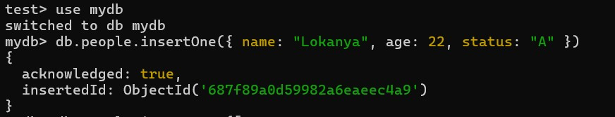

➤ Insert Multiple Documents:
db.people.insertMany([
{ name: "Alice", age: 25, status: "B" },
{ name: "Bob", age: 30, status: "A" },
{ name: "Charlie", age: 28, status: "C" }
])

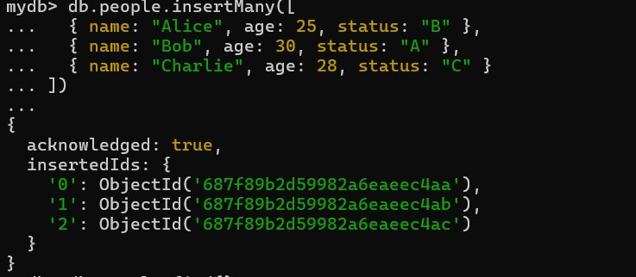
2. Finding Data
➤ Find All Documents:
db.people.find()

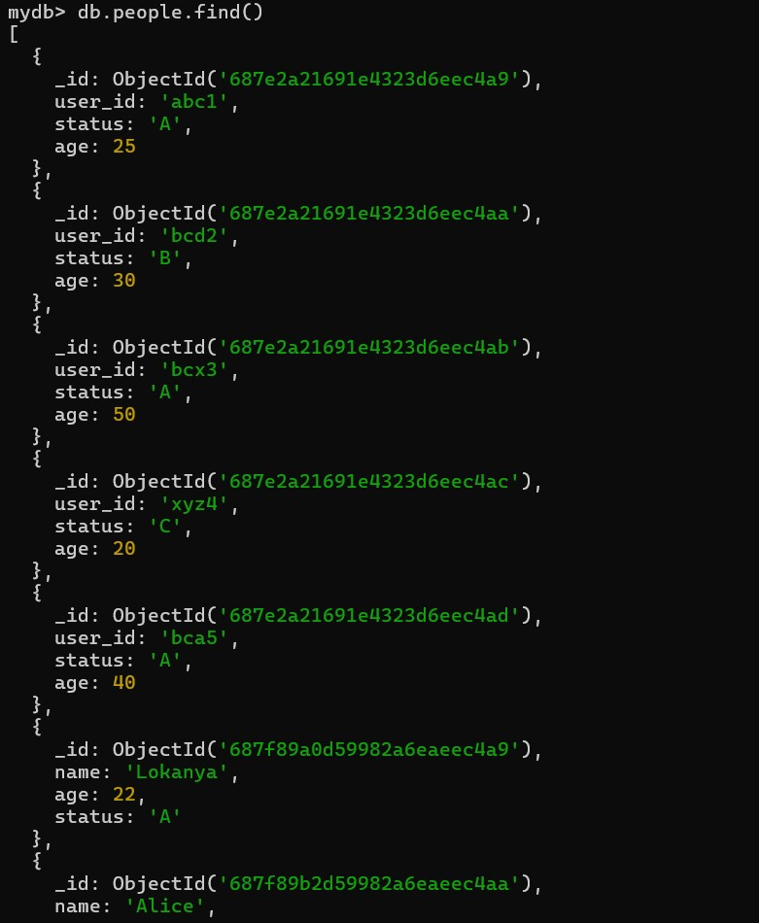

➤ Find with Filter:
db.people.find({ status: "A" })

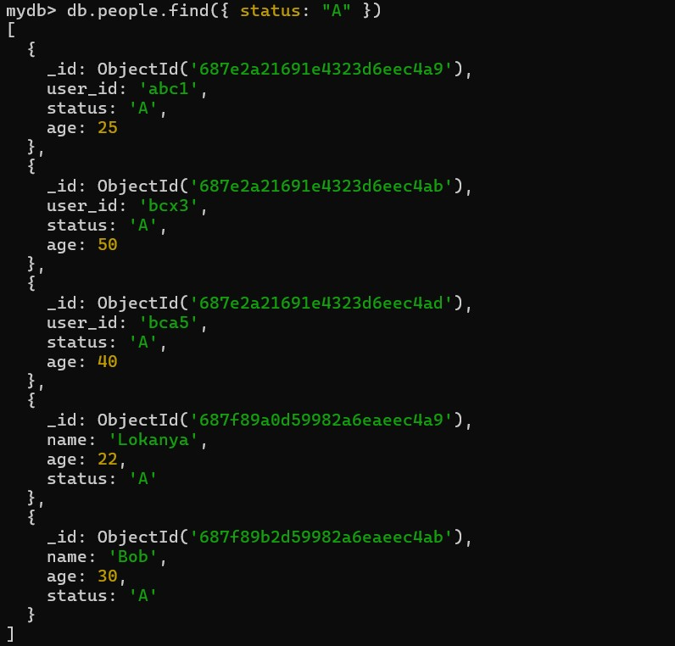

➤ Find Only One Document:
db.people.findOne({ name: "Alice" })
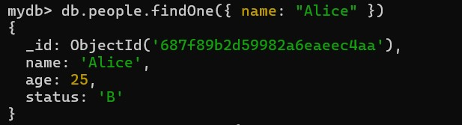
3. Updating Data
➤ Update One Document:
db.people.updateOne(
{ name: "Bob" },
{ $set: { age: 35 } }
)

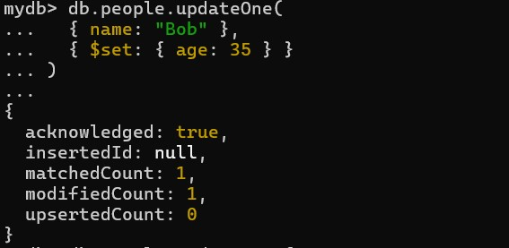

➤ Update Many Documents:
db.people.updateMany(
{ status: "A" },
{ $set: { active: true } }
)

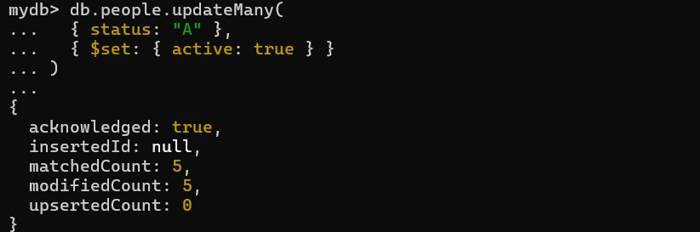
4. Deleting Data
➤ Delete One Document:
db.people.deleteOne({ name: "Charlie" })

➤ Delete Many Documents:
db.people.deleteMany({ status: "B" })

➤ Find and Delete One Document:
db.people.findOneAndDelete({ name: "Alice" })

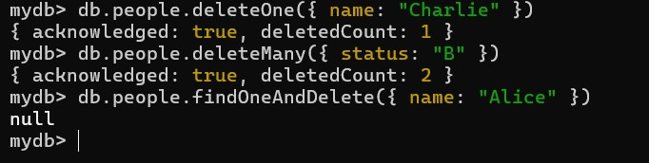

Display only name and age
db.people.find({}, { name: 1, age: 1 })

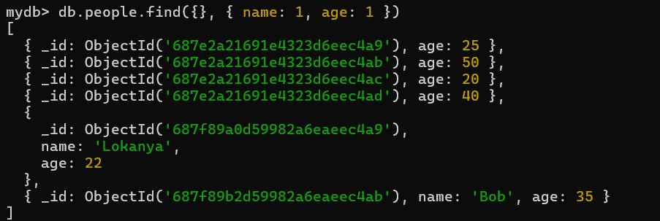

Display name and age but exclude _id
db.people.find({}, { name: 1, age: 1, _id: 0 })

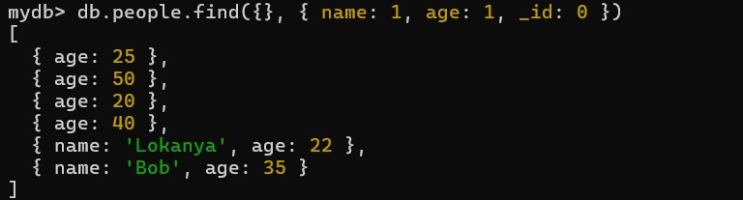

Display name and status without _id
db.people.find({}, { name: 1, status: 1, _id: 0 })

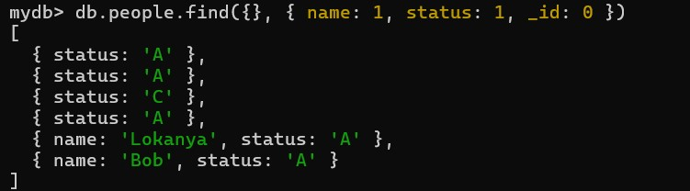

Display name and status of people whose age is 25
db.people.find({ age: 25 }, { name: 1, status: 1, _id: 0 })
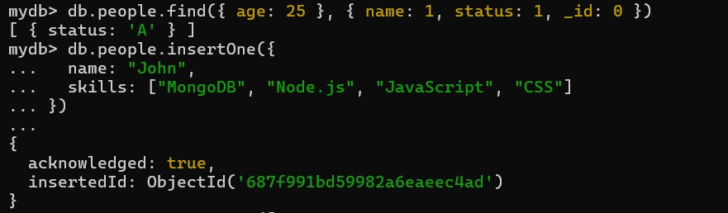
Add Array Data to Use $slice and $elemMatch
Add One Document with skills Array:
db.people.insertOne({
name: "John",
skills: ["MongoDB", "Node.js", "JavaScript", "CSS"]
})
Use $slice to get first 2 skills
db.people.aggregate([
{ $project: { name: 1, skills: { $slice: ["$skills", 2] } } }
])

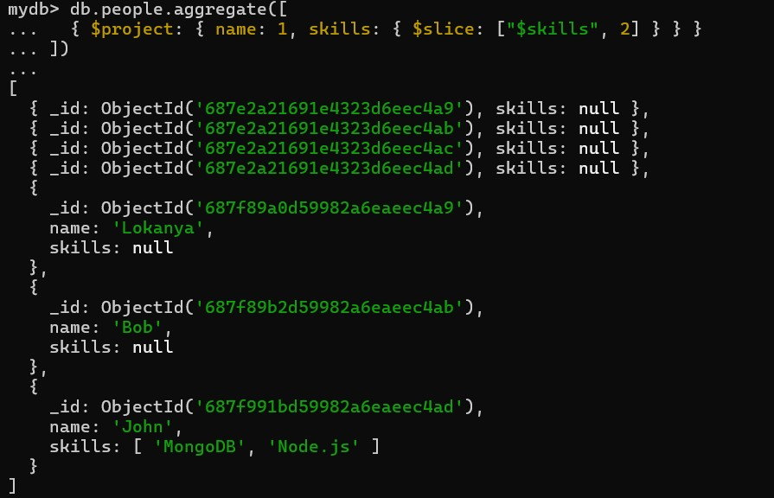

>> db.people.find({}, { name: 1, age: 1, _id: 0 })

